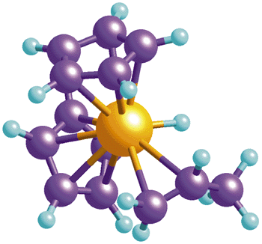
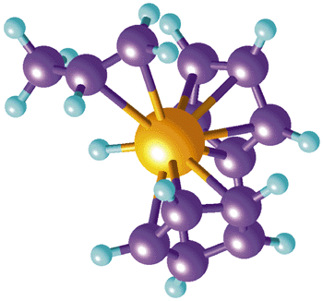
Integrated Physics and Chemistry
Syllabus
Fall 2017 – Spring 2018

Instructor | Mr. Mike Froehlich
Room(s) | V101, V103, N226
Phone | 281-920-8000
Email | mfroehli@houstonisd.org
Tutorials | Mon, Tue LUNCH N226

Required Supplies

- Scientific calculator
(Students will NOT be allowed to use their cell phones as calculators or borrow calculators from another student during quizzes/tests.)
- 3-ring binder with loose-leaf paper and 5 dividers
- Folder with pockets
- Pens and Pencils
- LAPTOP

Grading Policy
- 70% (Major Grades): tests, major labs, major projects
- 30% (Minor Grades): daily grades, quizzes, homework, etc.

Retake Policy:
Each six weeks you will be given the opportunity to retake one test with a grade less than 80. You have to show up to tutorials to retake the test, and you need to have completed all homework related to the test material. Any major grade that is not a test, such as a project or a lab, will be ineligible for retakes. The maximum score for any retest is 80. If the grade on the new work is also below 80, then you will receive the higher score of the two tests.
Absences (General): When absent, it is the student’s responsibility to check the lesson plans online, ask the teacher for missed work, and make up work.

Testing
I take it testing very seriously. Understand that if a phone or other electronic device is visible or used during a test, the test will be invalidated. The electronic device will be picked up according to WHS policy and the student’s test materials will be immediately picked up and not returned. A zero will be assigned for the test unless a retake is completed per the WHS retake policy. If a retake has already been completed for that six weeks, the student will not be able to retake the invalidated test and will keep the zero.

Absences the day of a lab, quiz, test, or due date: You will take the quiz or test THE DAY YOU RETURN TO CLASS. Turn in the assignment on the day you return with no penalty for excused absences. Make arrangements with me to do make-up labs during tutorials. If you have been absent several days prior to a quiz or exam, speak with me to schedule the new test or quiz date. Unexcused late work will be penalized with 11 points for the first day late, and an additional 10 points for each week it is late after that.

Student conduct: Students are expected to follow laboratory safety rules, HISD’s code of student conduct, and any conduct rules established in class.

IPC Course Objectives 2017-2018

Material to learn this year:

- Safety & Graphing
- Density
- Speed, Velocity, and Acceleration
- Motion and Forces
- The Atom
- The Periodic Table
- Classification of Matter
- Nature of Matter
- Chemical Solutions
- Acids and Bases
- Chemical Bonds
- Chemical Reactions
- Atomic Bonding
- Heat and Energy
- Simple Machines
- Electricity and Magnetism
- Mirrors and Lenses
- Color
- Waves and Sound



- - - - - - - - - - - - -- - - - - - - - - - - -- - - - - - - - - - - -- - - - - - - - - - - -- - - - - - - - - - - -- - - - - - - - - - - -- - - - - - - - - - - -- - - - -

I understand the classroom policies and procedures and pledge to respect and abide by them.

Print Name _____________________________

Signature _______________________________

Date _____________________

